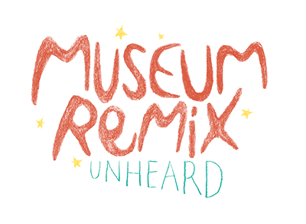
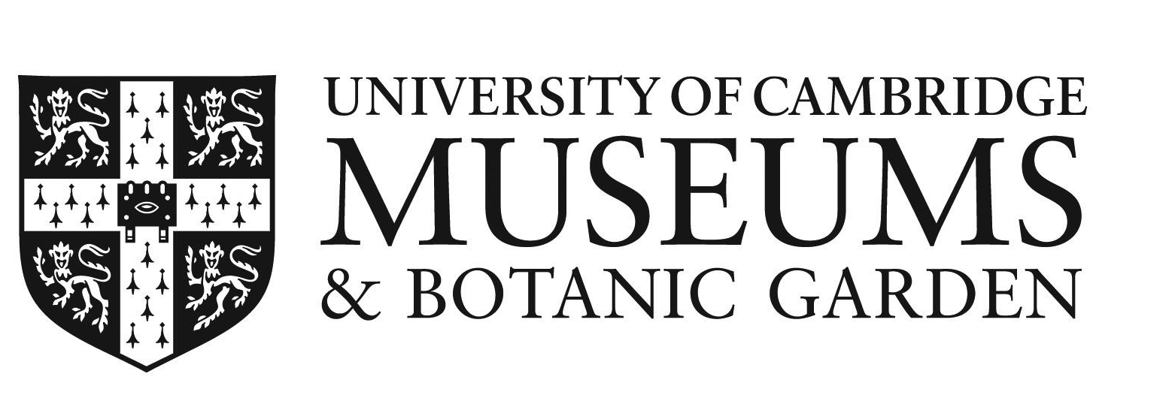

Museum Remix: Unheard
Participant Agreement Form
Code of Conduct
This University of Cambridge Museums (UCM) project is based on the values of collaboration, innovation, inclusion and experimentation. We strive to provide a safe, inclusive and welcoming environment for all participants.
We encourage freedom of speech and open activity. Discrimination or any form of exclusion will not be tolerated. Museum Remix: Unheard reserves the right to refuse and / or remove content which violates these principles. Museum Remix: Unheard is not liable for anyone’s specific views and opinions.
Intellectual Property Rights
The concepts, ideas and submissions that will be exchanged and submitted during Museum Remix: Unheard are public. Authorship on creative works submitted from Museum Remix participants is licensed under Creative Commons BY-SA: anyone is free to share and adapt the material as long as the person gives appropriate credit, provides a link to the license, indicates if any changes were made and distributes the transformed material under the same license as the original. You can use closed source software if you inform other team members and local organizers (to avoid subsequent rights issues). https://creativecommons.org/licenses/by-nc-sa/3.0/ , https://creativecommons.org/licenses/by-sa/3.0/
Participants must abide by copyright restrictions on any material they use in their submissions including use of music, sounds, images or video.
By providing a submission to Museum Remix, each participant represents and warrants that the submission does not violate any applicable law or any third party intellectual property rights.
Under the Creative Commons BY-SA licence, the UCM may share my creative submission on social media, on the UCM website (www.museums.cam.ac.uk), within UCM museum spaces, and on UCM collections databases.

After Museum Remix: Unheard
Use of works
If I have the opportunity to develop my submission after the Museum Remix. I agree to inform the University of Cambridge Museums via museumremix@museums.cam.ac.uk . I also understand that this new production has to be distributed under the same license (Creative Commons BY-SA).
Storage of works
The University of Cambridge Museums will store submissions collectively under this licence until the last day in April 2023. All Museum Remix participants will be able to request access to their submissions via museumremix@museums.cam.ac.uk until this time.
Access to works
All Museum Remix participants have the right to contact the UCM and ask for their submissions to be taken off display, or anonymised.
Name:
Date:
Signed:

