Whipple Museum: Group Leader notes for taught sessions

Thank you for bringing your group to the Whipple Museum! Here is the general information we think you need for your visit. You will also receive a session timetable and our school visits risk assessment. If you have any questions, contact Alison on are26@cam.ac.uk.

Getting here
We ask groups and schools to use our accessible entrance, which is step free. Please take care on the new museums site as there may be traffic moving around. If you know that you are going to be late, please phone Alison on 07855 184549 to let us know when you are likely to arrive. Coaches can drop off on Pembroke Street but there is nowhere near the museum for them to park.
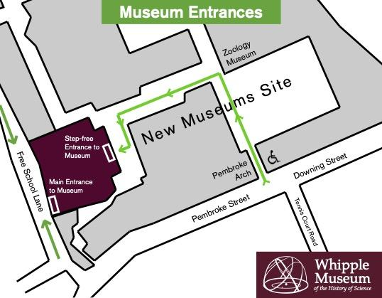
Toilets
The museum has two toilets, one at the entrance and one off the learning gallery. The one at the entrance is an accessible toilet but children need to be accompanied to it. Unless you have group members with additional needs it’s best to plan to use the one in the learning gallery. Please don’t plan for everyone to use the toilet at the start or end of the visit because it takes a lot of time!

Eating
We’re sorry, the museum has no spaces where children can eat lunch or snacks. If the weather is warm there is space on the steps up to the Zoology museum where a class can sit and eat. Downing Place URC is a 10-minute walk away along Downing Street and hires out its hall for school groups. You can find more details at https://downingplaceurc.org/about/facilities/.

Security
If you are visiting in the morning, you will have the museum to yourself. You can leave bags etc. in the learning gallery. In the afternoons the museum will be open to the public. You can still leave bags in the gallery but it is recommended that you keep any valuables with you.

Behaviour in the museum
We’re delighted to welcome visitors of all ages to the museum. Please encourage your group to think about how they can keep themselves and our objects safe while you are at the museum. We ask all visitors to:
- Walk in the galleries and on the stairs
- Only touch objects which are introduced as handling objects (there will be plenty of those)
- Be considerate of other people in the museum.
Questions and conversations are very much encouraged!

Adapting sessions
One of the great things about being a small museum is that we can be very adaptable. If we can help someone in your group by making changes to the session, please let us know. We want everyone to feel happy and comfortable in the museum.

Before and after your visit
The University of Cambridge museums have a range of activities to do at school or at home. You can find them at https://www.museums.cam.ac.uk/activities. You can filter the results to find activities which relate specifically to your visit, or explore objects from the other museums. After your visit we will send you a short evaluation form. We would be very grateful if you could fill this in with your class or group. This will help us to know what people think of our visits and to make them better for everyone!

