HERO – HYBRID

Ancient heroes came in all shapes and sizes. In this activity you will make your own hero inspired by our collection!

You will meet a few of the gods, goddesses and heroes from our museum. First, match the description to a statue from our museum. Second, create your own!

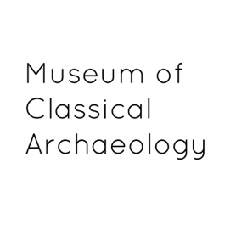
Key Words
Special Power: this is the thing that the person or god are really good at. Think of it as their talent.
Physical Attribute: most Greek Gods and Goddesses could be identified by an accessory, a symbol or something they owned.
Character Trait: everybody has those! Sometimes heroes are great, but they also have flaws. Remember that no-one, not even the gods are perfect in Greek myth.
Appearance: how do they appear in Greek art?

 | Special Power | Physical Attribute | Character Trait | Appearance
Athena | Wisdom,  Strategy, | shield, spear, aegis (armour)  Owl | proud,  quick to judge  vengeful | bright eyes  tall and imposing
Hercules | Strength | club, lion skin | remorseful, patient | big, muscular
Apollo | Music,  Health & Medicine | lyre  bow and arrows  lizard | vengeful | beardless, young, good hair
Odysseus | Resourcefulness | traveller’s hat | inventive, smart, cunning, loyal | ragged, handsome, bearded
Nike | Granting Victory, Flying | wings | fair | wings, young
Ariadne | Strategic Thinking | wool, crown | wise, helpful | beautiful, young
Zeus | Thunder, Storms, Power over other gods | thunderbolt | just | beard, tall, muscular
Match the descriptions of these gods, goddesses and heroes to the pictures on the next page.

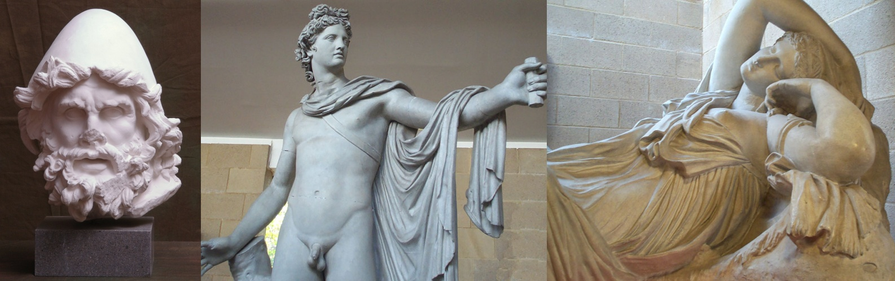
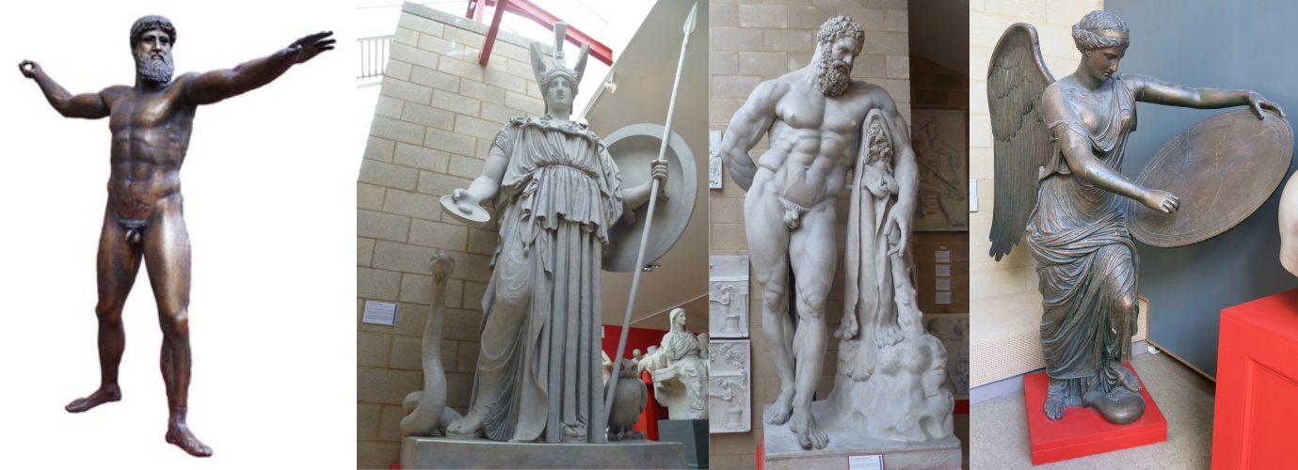
Make Your Own Hero or God
On a piece of paper draw a table like the one below. Choose what special powers, physical attributes, character traits, and appearance you want them to have and write them out. Then try to draw each.
You need to give them a name too. Male names in ancient Greece often end with -us, -os, or -es. Female names often end with ‘a’ or ‘e’.
Physical Attributes
Special Powers

Appearance
Character Traits
Here is a new hero our Education Coordinator created. She run out of colouring pens though!

